Last Name: **Click here to enter text.**

First Name: **Click here to enter text.**

Phonetic Pronunciation: **Click here to enter text.**

Student ID: **Click here to enter text.**

*All pages in this application (including extra attachments) should be:

Printed **single-sided** & **paper-clipped** together (no staples) – Please **type** all information.

Only use standard white paper – no color paper, or thick/cardstock, etc.

|  |  |
| --- | --- |
| **1. Due Date**  This application is due by **April 28, 2023** (by 4:00pm) to the I.H.S. Office (Mrs. Baltzell) or to your Primary Teacher.  **2. Self-Reflection/Personality Inventory Worksheet Required**  You will need to {1} create a CaCareerZone.org account using the Educator Account Code CW57K1{2} Take the Interest Profiler {3} Complete the CaCareerZone Worksheet located on this application and print it out. Don’t forget to put your name on it. | **4. Application Essay/Question Required**  You will need to attach a response to the prompt listed below that is: [1] typed, [2] single-spaced, [3] formatted in 12pt Times New Roman, & [4] ***At least*** 1 FULL paragraph.  Your response should fully address the following prompt: **Describe the world you come from** (e.g., your family, community, or school) **and tell us how your world has shaped your dreams and aspirations**. |
| **3. FAFSA or CA Dream Act** – Show proof you have completed the application for the 2023-2024 School Year  (Print out a copy of the email sent to you that states “Processed Successfully” - See Example located below this application..  It’s OK if you missed the March 2nd deadline. Complete the FAFSA or CA Dream ACT as soon as you can!  Directions on how to complete the FAFSA or CA Dream ACT are on the counseling tile located in Canvas. Contact Ms. Abono at [abonos@luhsd.net](mailto:abonos@luhsd.net) if you have questions about these forms. | **5. Confidential Teacher Report Required**  Contact two teachers and request that they fill out the *“****Confidential Teacher Report****”* form. The teacher will be commenting on the student’s academic strengths, attitude on campus, personality, leadership abilities, etc. (The office will give the teachers the forms after you have completed and returned the rest of the application to the office)  Which 2 teachers will be completing your forms?  *Teacher Name:* **Click here to enter text.**  *Teacher Name***: Click here to enter text.** |

**6. Parent/Guardian Signature**

Independence High School is granted permission to release educational information to organizations conducting their own selection process for awarding scholarships. This information may include this application, the application essay, an academic transcript, senior year attendance record, recommendations, teacher evaluations, etc.

ACKNOWLEDGEMENT: I understand it is my responsibility to submit a completed application, together with all supporting documents, including a **Response to writing prompt, CaCareerzone.org Worksheet, Proof of FAFSA or CA Dream Act Completion** and a **Confidential Teacher Report Form request**, and that all documents are received no later than **April 28, 2023 4:00 pm deadline** in order to be considered for the *Independence High School Local Scholarship Program*.

**I have completed this application with honesty and integrity and confirm everything to be true and I.H.S. is granted permission to release educational information to organizations for the purpose of applying for scholarships: (applications, transcripts etc.)**

Parent/Guardian Signature: _____________________________________ Date:

Student Signature: __________________________________________ Date:

**Page 1 of 10**

**Student Profile**

|  |  |
| --- | --- |
| Last Name: **Click here to enter text.** | Address: **Click here to enter text.** |
| First Name: **Click here to enter text.** | City: **Click here to enter text.** |
| Student Personal Email: **Click here to enter text.** | Student Cell Phone: **Click here to enter text.** |
| Elementary School Attended: **Click here to enter text.** | Middle School Attended: **Click here to enter text.** |

**What type of college/school do you plan to attend next year?**

Community College 4-year College  Trade/Technical School  Other

**Which colleges/schools did you apply to?**

|  |  |
| --- | --- |
| school 1: **Click here to enter text.** | school 2: **Click here to enter text.** |

**If you know what you want to study in College or Program please let us know.**

**Please also let us know a Career Goal that you might like to consider.**

|  |  |
| --- | --- |
| Academic Major: **Click here to enter text.** | Career Goal: **Click here to enter text.** |

**Parent/Family Profile**

**Marital Status**

Married  Single  Separated  Divorced  Widowed

**Parent Employment Information**

|  |  |
| --- | --- |
| Father’s/Guardian’s Occupation: **Click here to enter text.** | Father’s/Guardian’s Employer: **Click here to enter text.** |
| Mother’s/Guardian’s Occupation: **Click here to enter text.** | Mother’s/Guardian’s Employer: **Click here to enter text.** |
| If Parent/Guardian is an employee of one of the following school districts please indicate below:  Liberty Union, Brentwood, Knightsen, Byron :  **Click here to enter text.** | Name of school Parent/Guardian works at:  **Click here to enter text.** |

Confidential Family Information: (Optional Information that is helpful in matching you with certain scholarships)

1. Parent’s combined gross Income in 2021: **Click here to enter text.**
2. Total $ Student has saved: **Click here to enter text.**
3. Are you employed? **Click here to enter text.** If yes, then where and how long? **Click here to enter text.**
4. Are you a U.S. Citizen: **Click here to enter text.**
5. Indicate your ethnic background: **Click here to enter text.**

Example: White, Black, Hispanic, Filipino, Pacific Islander, Asian, American Indian

**2 of 10**

1. Please list any organizations, clubs or local unions in which you or your parents are members:

**Click here to enter text.**

1. With whom do you live? **Click here to enter text.**
2. How many people in your immediate family (including you) will be attending college next year? **Click here to enter text.**
3. Explain any circumstances that have caused a financial burden for your family: **Click here to enter text.**

**Checklist**

(Indicate with an X that you have included needed information)

1. Complete, printout and signed application. Click here to enter text.
2. Completed ***cacareerzone.org*** worksheet: **Click here to enter text.**
3. Printout of confirmation that your FAFSA or CA Dream Act Applications have been processed: **Click here to enter text.**
4. Completed Essay Prompt “**Describe the world you come from** (e.g., your family, community, or school) **and tell us how your world has shaped your dreams and aspirations**. **Click here to enter text.**
5. Provided the names of 2 teachers who are willing to complete a Confidential Teacher Report for you. **Click here to enter text.**
6. Deadline to submit application is Friday, April 28, 2023
   1. Email to: [abonos@luhsd.net](mailto:abonos@luhsd.net) or
   2. Hand deliver to I.H.S. Main Office or
   3. Mail to: Attn: Scholarship Applications, 929 2nd Street, Brentwood, CA 94513

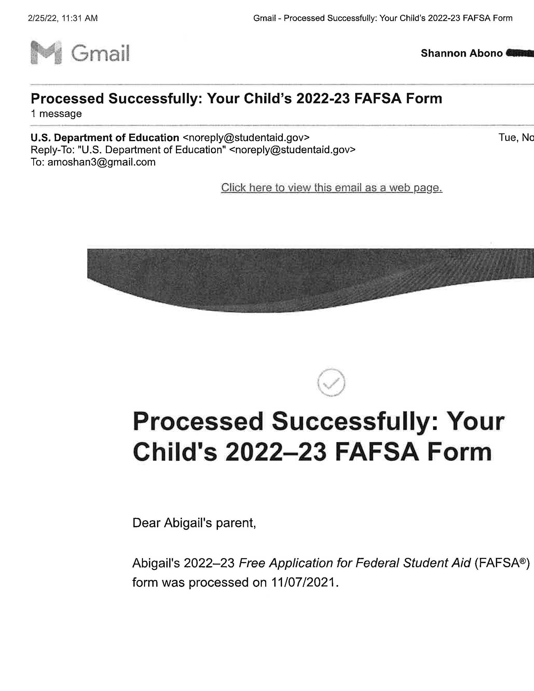

Example:

**Click on Link Below for Information on Financial Aid Forms**

Information on [FAFSA](https://studentaid.gov/apply-for-aid/fafsa/filling-out) and [CA Dream Act](https://dream.csac.ca.gov/landing)

**Page 3 of 10**

Name: **Click here to enter text.** Date: **Click here to enter text.**

Independence High School Scholarship

Career Exploration Research Worksheet

Go to [www.cacareerzone.org](http://www.cacareerzone.org) to log into account. If you do NOT already have an account please see directions attached at the bottom of this worksheet on page 7 about how to create an account.

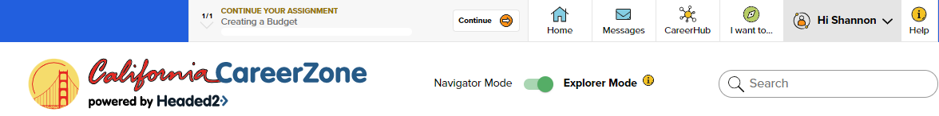

To take the Interest Profiler click on this box: Please see directions on how to complete the Interest Profiler on page 8 of this document



Then research at least 1 job or career and answer the questions on the worksheet by clicking on this box:



If you have a job/career in mind, Click on “Explore California Industry Sectors” – Click on an Industry Group or Type the name of the job up in the right hand corner where it states “Search”.

My top three Interest areas are: **Click here to enter text.**  **Click here to enter text. Click here to enter text.**

Job/Career you are exploring: **Click here to enter text.**

What ***Job Zone*** number is it in? **Click here to enter text. (What level of Education do you need to do this job or career?)**

**4 of 10**

What ***Occupation Cluster*** is it in? (See name of cluster next to picture under title of career) **Click here to enter text.**

What Interest Code is associated with this job/career? **Click here to enter text.**

Do you feel your personality type would be a good fit for the job/career you are researching? **Click here to enter text.**

What ***Work Values*** are associated with this job/career? **Click here to enter text.** **Click here to enter text. Click here to enter text.**

What is the average Salary for this job/career? $ **Click here to enter text.**

What are the projected # of total annual openings for this job/career? (Hover over Annual Openings) **Click here to enter text.**

How many positions in this job/career will there be by the year 2030? (Hover over Annual Openings) **Click here to enter text.**

Briefly describe this job/career (***About the Job***): **Click here to enter text.**

Briefly describe 3 job responsibilities (***What they Do***): **Click here to enter text.** **Click here to enter text. Click here to enter text.**

What are 3 things people in this job/career ***Need to Know***? **Click here to enter text.** **Click here to enter text. Click here to enter text.**

What are 3 ***Things you need to be able to do?* Click here to enter text. Click here to enter text. Click here to enter text.**

What are 2 ***Industry’s that are employing*** people for this job/career? (Look under Pie Chart)

 **Click here to enter text. Click here to enter text.**

List 2 ***Similar Occupations***: **Click here to enter text. Click here to enter text.**

***Click on the Find Institutions Box then Click on View All***

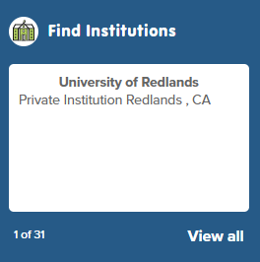

Choose between 1 and 3 ***Institutions (College, Major, Certificate or Training Program)*** and answer the following questions after clicking on:

**5 of 10**

College/Training or Certificate Program **Click here to enter text.**

How many students attend the College/University or Training Program (TP) of your choice? **Click here to enter text.**

Describe one aspect of the ***Student Body*** makeup that is interesting to you: **Click here to enter text.**

What is the ***Setting***: (i.e. Small Town, Suburban or Large City?) **Click here to enter text.**

Is this a ***Public or Private*** College/University/Training Program? **Click here to enter text.**

What is the 2021 ***Annual Average*** ***Tuition Cost*** for this College/University/TP? **(In State**) $ **Click here to enter text.**

***(Out of State***) $ **Click here to enter text.**

What is the 2021 ***Annual Average Room and Board*** for this College/University or TP? $ **Click here to enter text.**

What is the 2021 ***Annual Average Cost of Books and Supplies***? $ **Click here to enter text.**

What % of students receive ANY form of Financial Aid? % **Click here to enter text.**

What is the Average dollar amount of Financial Aid that students receive each year? **Click here to enter text.**

How much “Loan Aid” does the average student incur at this institution each year? $ **Click here to enter text.**

**(You might want to use the *Net Price Calculator* on the institutions website if you want to know how much it would cost for you.) You can find the link for this under** 

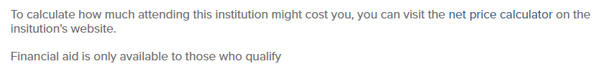

*Please print out this completed worksheet and include it with the rest of the Independence High School Local Scholarship Application.*

**6 of 10**

***Creating a California Career Zone Account***



1. Click on “Create a Free Account

2. Use school email address (This is also your user name)

3. Create a Password

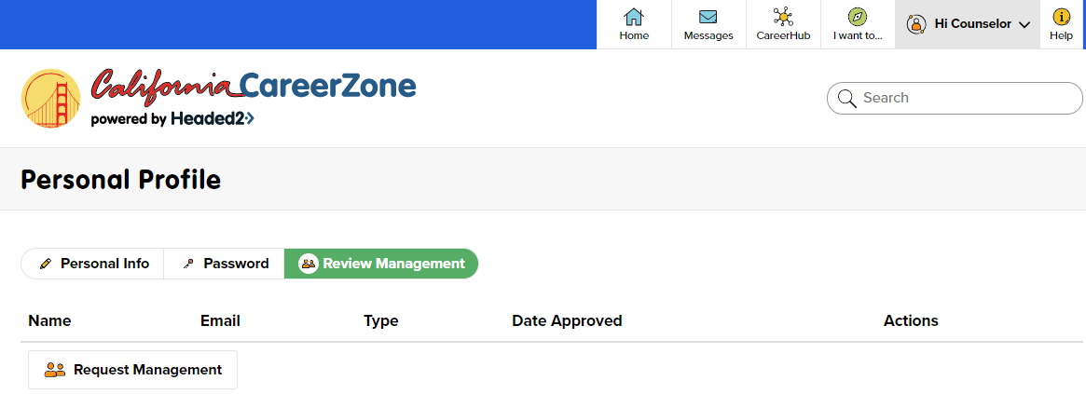

4. Click on “Hi (Your First Name)

5. Click on Review Management

6. Click on REQUEST Management

7. Type in CW57K1 in the Navigator Code box and then click on Request Navigator

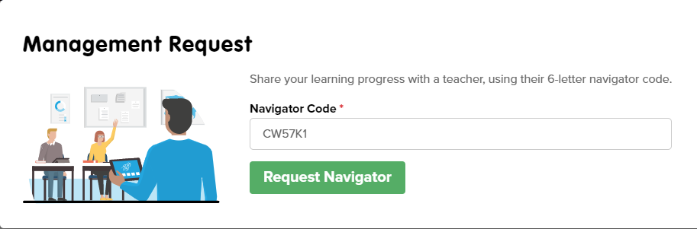8. Once you click on Proceed you will now be part of my class in CCZONE.

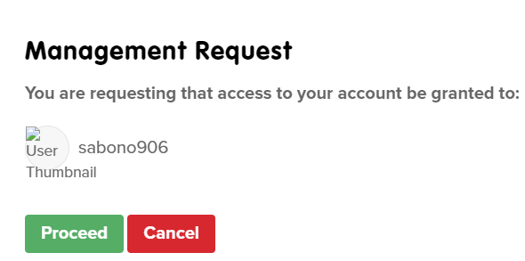

**7 of 10**

***Create a Plan & Take The Interest Profiler***

9. Click on Create a Plan

10. Select “Know yourself, know what drives you” as your first Goal



11. Once you see the Career Exploration box click on Start

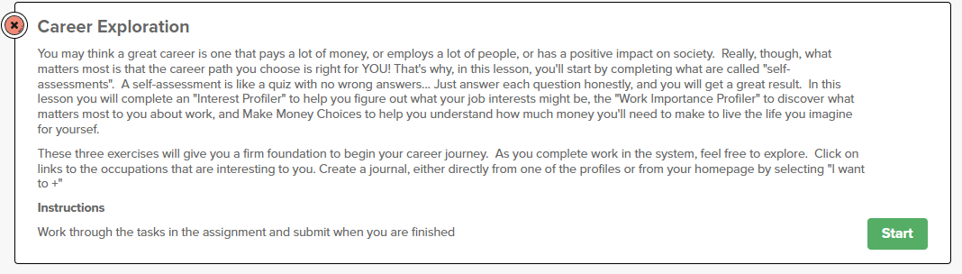

12. Click on “Go to the Interest Profiler

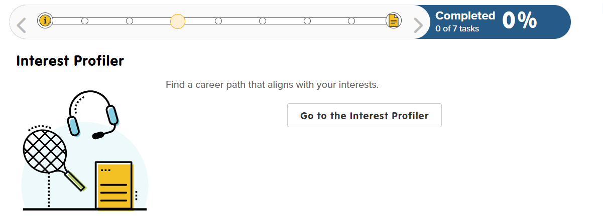

**8 of 10**

13. If you don’t finish and you save your work the best way to get back to the Interest Profiler is to click on the little yellow page… scroll down and click on “Interest Profiler” again





14. Click on “Start a new Interest Profiler and GO”

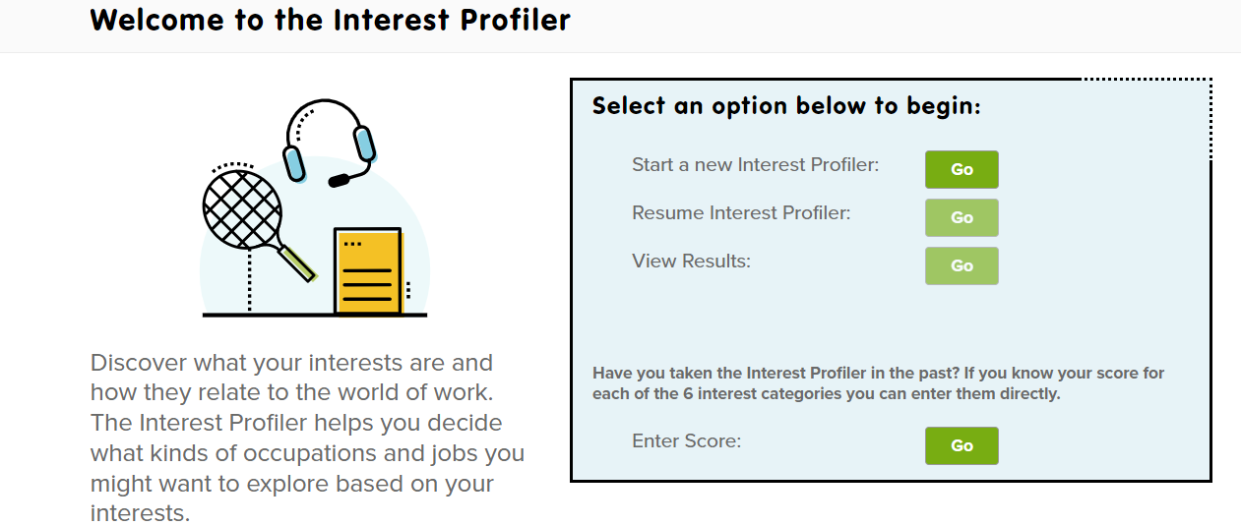

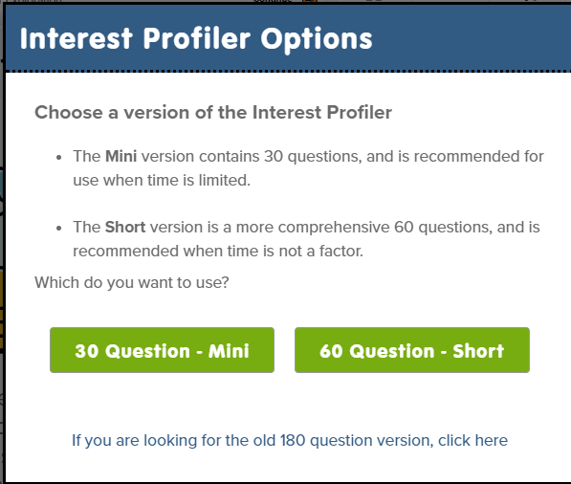15. Click on the 60 Question Box

**9 of 10**

16. Helpful Hints

A. Do NOT click the Unsure  Emoji for everything. If you click on the same Emoji over and over again your results will be skewed and will NOT reflect your true interests.

B. Do not take the questions LITERALLY. (Use your imagination!)

i. If it asks you if you want to write a book and you have no desire to write a book…but you want to start a Video Blog (VLOG) on your social media app then say YES you want to write a book!

ii. If it asks you if you want to build a Kitchen Cabinet but you don’t want to specifically build a Kitchen Cabinet (Maybe you want to rebuild an engine in your dad’s old car) Click on the Like Emoji!

C. This questionnaire is trying to figure out what You MIGHT be interested in. It is not looking to find your ultimate Career. This is a starting point only.

At the end of the questionnaire you will be given a set of scores: Write them down here:

1: R:__________________ 4: S:___________________

2: I:__________________ 5: E:___________________

3: A:__________________ 6. C:___________________

What were your 3 highest scores? What is their corresponding letter?

This is your Interest Profiler Code!

1: __________________ (Highest)

2: __________________ (Next Highest)

3: __________________ (3rd Highest)

**10 of 10**